PERSON COMPLETING REPORT
Full Name:
Position: |  |  |  | Trainer / Administration / Student / Employer / Other
Date: |  |  |  | ____ / ____ /____
INCIDENT DETAILS
1. |  | Describe the incident:
2. |  | Date and time incident occurred:
 |  | Date: ____ / ____ /____ |  |  |  |  |  |  | Time: ____:_____ am / pm
3. |  | Where did the incident occur:
 |  |  | - Training Room  - Kitchen  - Toilets  - Administration Office |  |  |  | - Main Office  - Within 5 meters of RTO  - On Work Placement  - Other _____________________________________
4. | What was the injured person doing at the time of the incident?
5. |  | Witnesses to the Incident:
 |  | Full Name:
 |  | Contact Details:
INJURY REPORT (if applicable)
1. | Details of Injured Person:
First Name:
Surname:
Title: |  |  |  | Employee / Contractor / Student / Visitor
Home Address:
Suburb: |  |  |  |  |  |  |  |  |  | Postcode:
Phone Number:
Date of Birth: |  |  |  | ____ / ____ /____ |  | Gender: |  | Male / Female / Neutral
2. | Location of Injury on Body: (circle on diagram below)  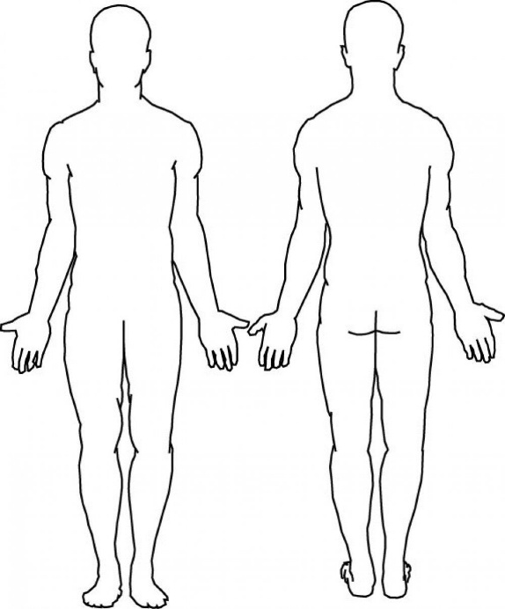
3. | Was medical treatment required? | Yes No
 | If yes, describe treatment and location
HAZARD IDENTIFICATION AND RISK CONTROL
1. | What hazard caused the incident?
2. | Were any control measures in place? | YES NO
 | If yes, please describe:
3. | Was Personal Protective Equipment (PPE) in use? | YES NO
 | If yes, please describe:
4. | Immediate Corrective Actions Taken:

 | INCIDENT INVESTIGATION
1. |  | Investigator Details
First Name
Surname
Title |  |  | Employee / Contractor / Student / Visitor
Date:
 | 2. | Hierarchy of Control Measures Implemented (select all that apply): |  |  | YES NO
 |  | If yes, please describe:
 | 3. | Psychosocial Factors Identified: |  |  | YES NO
 |  | If yes, please describe:
 | 4. | Was a WHS Risk Assessment Undertaken? |  | YES NO
 | 5. | Opportunity for Improvement Identified? |  | YES NO
 | 6. | Actions Discussed at Quality and Compliance Meeting? |  | Date: ___ / ___ / ______

ACTION TAKEN / REQUIRED
1. | Was the risk eliminated? |  | YES NO
 | If yes, please describe:
2. | Was a substitute introduced, isolated, or engineered to minimise risk? |  | YES NO
 | If yes, please describe:
3. | Were administrative controls put into place? | YES NO
 | If yes, please describe:
4. | Was PPE required to be introduced? | YES NO
 | If yes, please describe:

CONTINUOUS IMPROVEMENT
1. | How will this incident inform continuous improvement?
 | Were new risks or hazards identified? |  |  | YES NO
 | Describe changes to be implemented in policies, procedures, or training:
2. | Follow-Up Actions for Continuous Improvement:
3. | Date for Reviewing Improvements: |  | ___ / ___ / _____
RECORD KEEPING AND SUBMISSION
1. | Form Submission Details:
 | Submitted by:
 | Date:
2. | Storage and Record-Keeping:
 | Stored at:
 | Retention Period:
 | Register No: | WHS
 | Note: Once this form has been completed, forward it to the RTO Office for further action and monitoring.

FINAL SIGN-OFF
1. | Person Completing the Form:
 | Signature:
 | Full Name:
 | Date:
2. | WHS Officer Review:
 | Signature:
 | Full Name:
 | Date:

